

**SUBMITTED TO: SIR JAWAD KHAN**

**SUBMITTED BY: MUHAMMAD ZAOREZ**

**CMS ID: 455443**

**SEMESTER: 1ST SEMESTER (SEC A)**

**SESSION: UG ME-2023**

**COURSE TITLE: PROGRAMMING**

**COURSE CODE: CS-114**

REPORT WRITING

Write a C++ program to display factors of a number using for loops.

#include<iostream>

using namespace std;

int main()

{

// TASK 01

/*int n,factor;

cout<<"enter number: ";

cin>>n;

for(int i=1;i<=n;i++){

if(n%i==0){

cout<<i<<",";

}

}

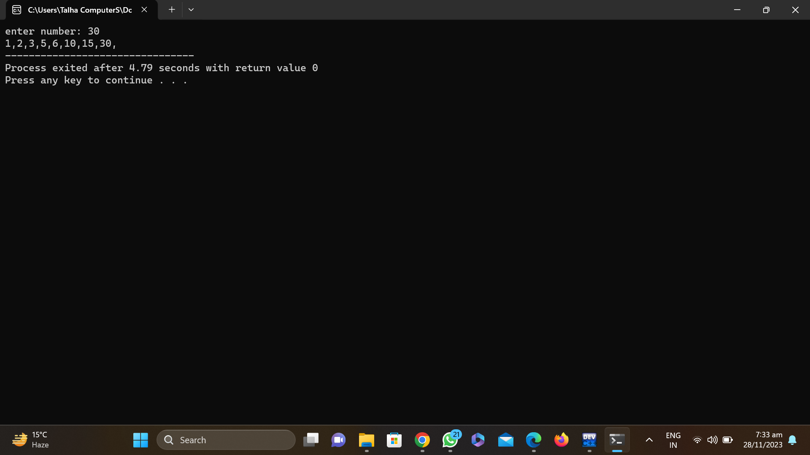

**Q(2):** Write output to the following code

ANS: THE OUTPUT OF THE TASK WILL BE X IS 5 AND Y IS 10 BECAUSE THE INTEGERS ARE DEFINED BY DEFAULT.

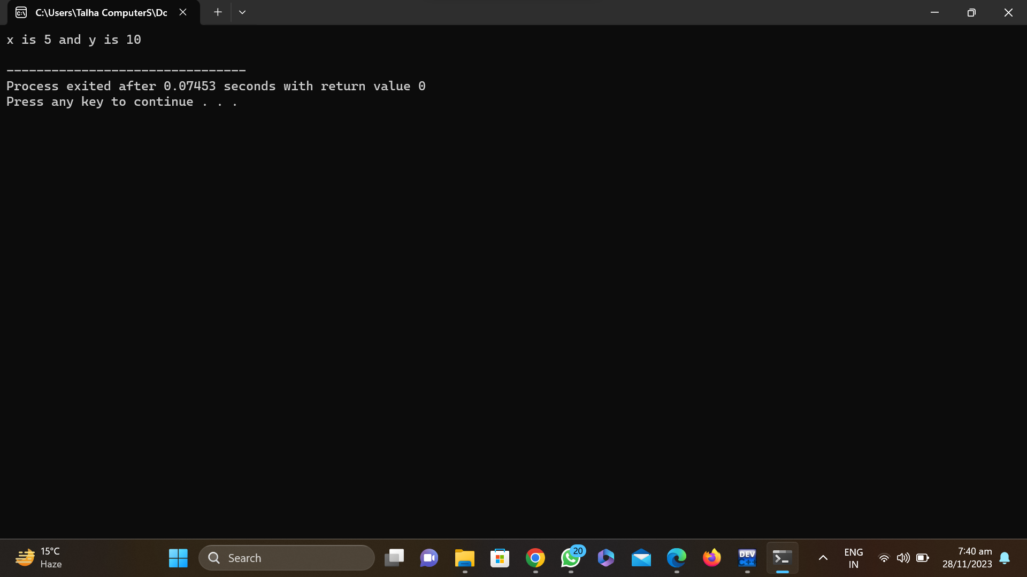

Q(3): Write a C++ program, take an integer value from user and check if it’s greater than 10 and less thanequal to 20. Print 1 if yes and print 0 if no. Use appropriate datatype for output

ANS: /*int n=0;

cout<<"enter number: ";

cin>>n;

if(n>10&&n<=20){

cout<<"1";

}

else

cout<<"0";*/

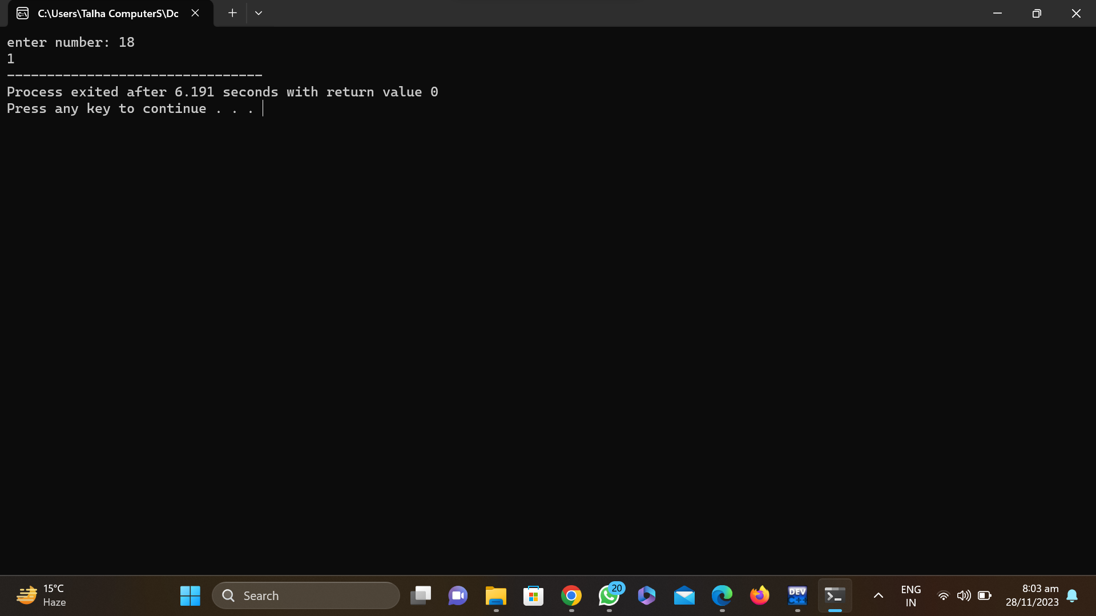

Q(6): Perform division in C++ without / using for loops. You can use / only to display the final results. Your dividend must be greater than divisor.

ANS: /*int dividend,divisor,i;

cout<<"enter dividend: ";

cin>>dividend;

cout<<"enter divisor: ";

cin>>divisor;

while(dividend>=divisor){

divisor=dividend+i;

i++;

}

cout<<"quotient is: "<<i;*/

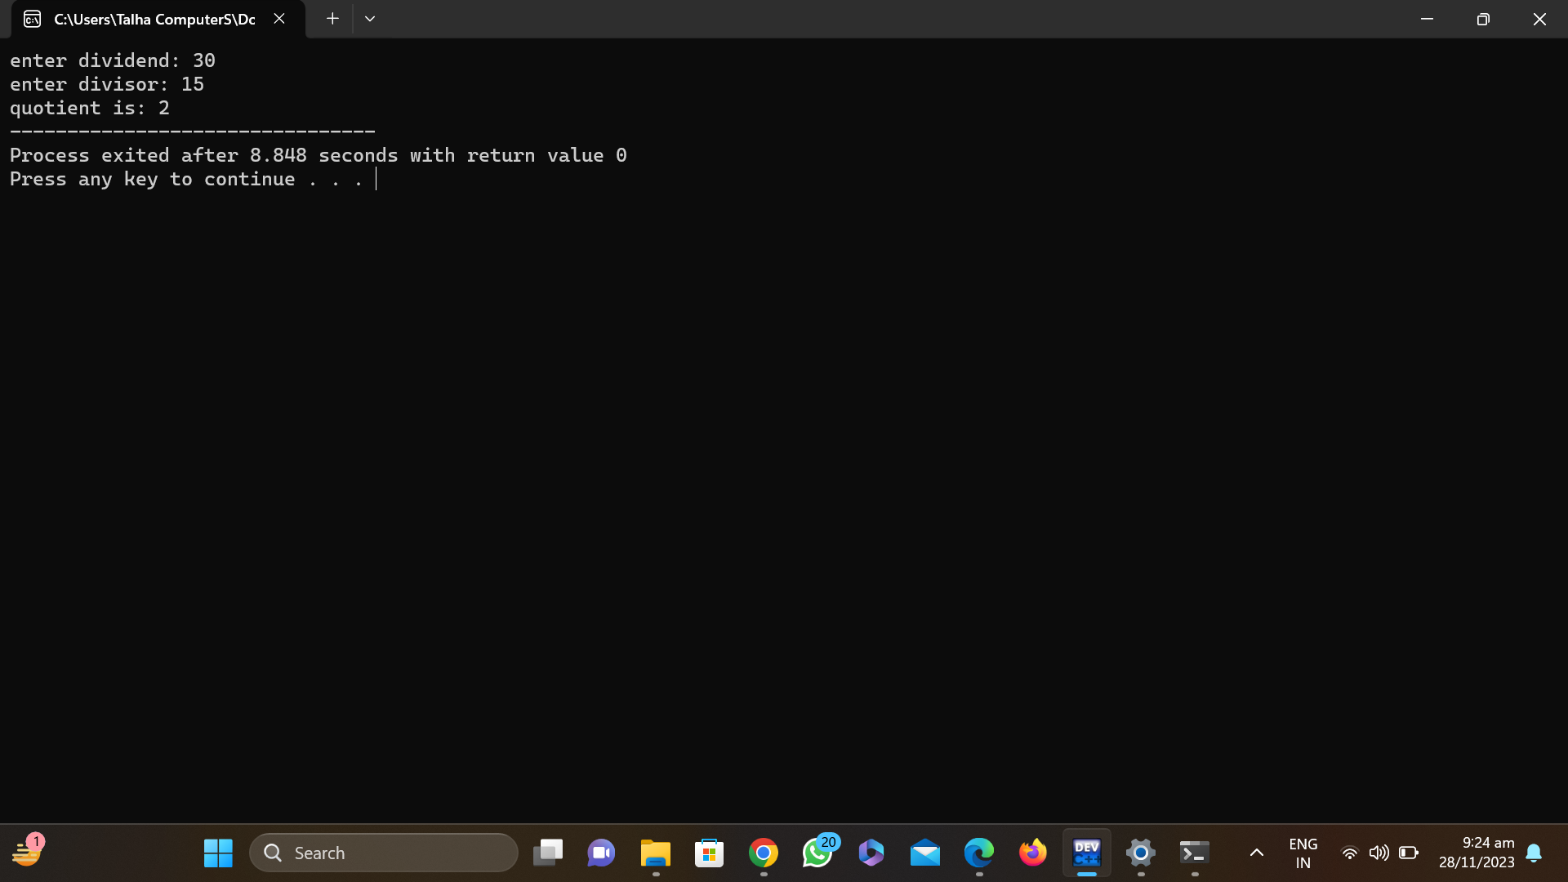

Q(8):. Suppose an integer array a[5] = {1,2,3,4,5}. Add more elements to it and display them in C++.

ANS:

a[5] = 6;

a[6] = 7;

a[7] = 8;

for (int i = 0; i < 8; i++) {

cout << a[i] << " ";

}

return 0;*/

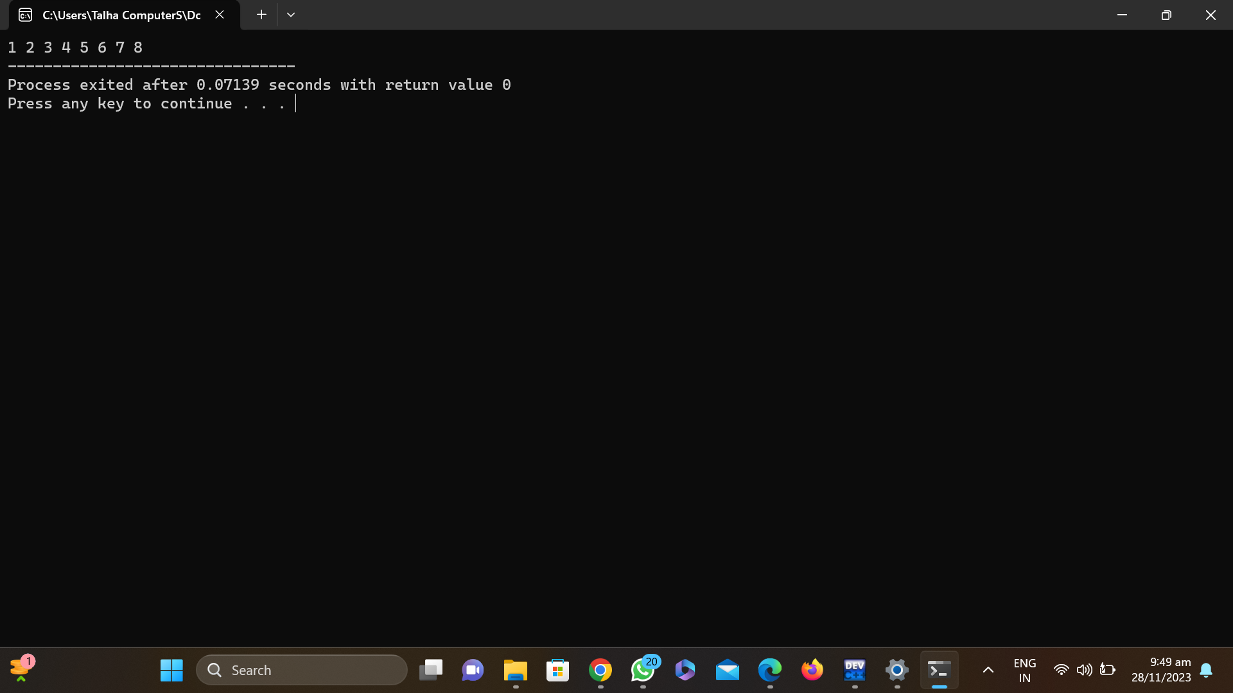

Q(10): Implement Bubble Sort on an array of 6 integers

ANS: CODE AVAILABLE IN PIC.IT WAS LOST BECAUSE IT WAS EXECUTED ON ONLINE COMPILER.

